

Medtronic

MUnit Developer Playbook

v1.0

Document Control Information

|  |  |
| --- | --- |
| Document Identification |  |
| Document Name | MUnit Developer Playbook |
| Project Name |  |
| Client | Medtronic |
| Document Author | Kishore Reddy Paluri |
| Document Contributors | MuleSoft Professional Services Team |
| Document Version | 1.0 |
| Document Status | Draft |
| Date Released |  |

Document Edit History

| Version | Date | Additions/Modifications | Prepared/Revised by |
| --- | --- | --- | --- |
| 1.0 | 03-Jun-2020 | Initial Version | Kishore Reddy Paluri |

Document Review/Approval History

| Date | Name | Organization/Title | Comments |
| --- | --- | --- | --- |
|  |  |  |  |
|  |  |  |  |
|  |  |  |  |

1. Introduction 4

2. MUnit Test Suites 5

2.1 Creating MUnit Test Suite from APIKit Router 5

2.2 Creating Test Suite for a Flow 7

2.3 Creating Test Suite for selective flows 8

2.4 Creating Testcase by recording the test 11

3. MUnit Event Processors 21

3.1 Assert 21

3.2 Assert Payload 21

3.3 Mock when 22

3.4 Unit Testing Best Practices 22

4. Mocking External dependencies 23

4.1.1 Mocking HTTP request 23

4.1.2 Mocking Database Select 24

4.1.3 Mocking Web Service Consumer 26

4.1.4 Mocking Read File 27

4.2 Code Coverage 28

4.3 Dataweave 29

5. MUnit Recommendations 30

5.1 Always define the media type in a Mock 30

5.2 Define the Environment Variables as Global Properties 30

5.3 Use Verify Event Processors 30

5.4 Assert a payload when it contains a timestamp 31

5.5 Test Connectivity Errors 31

6. References 32

# Introduction

MUnit is a Mule application testing framework that allows you to easily build automated tests for your integrations and APIs. It provides a full suite of integration and unit test capabilities and is fully integrated with Maven.

MUnit 2.2 support all versions of the Mule Runtime since 4.0.

For more information:

<https://docs.mulesoft.com/munit/2.2/>

# MUnit Test Suites

MUnit Test Suites can be generated in 4 different ways.

# Creating MUnit Test Suite from APIKit Router

This option automatically scaffolds a MUnit test suite based on the endpoints described on your API definition (RAML). Right-click over APIKit Router and select "Create Test Suite for...."

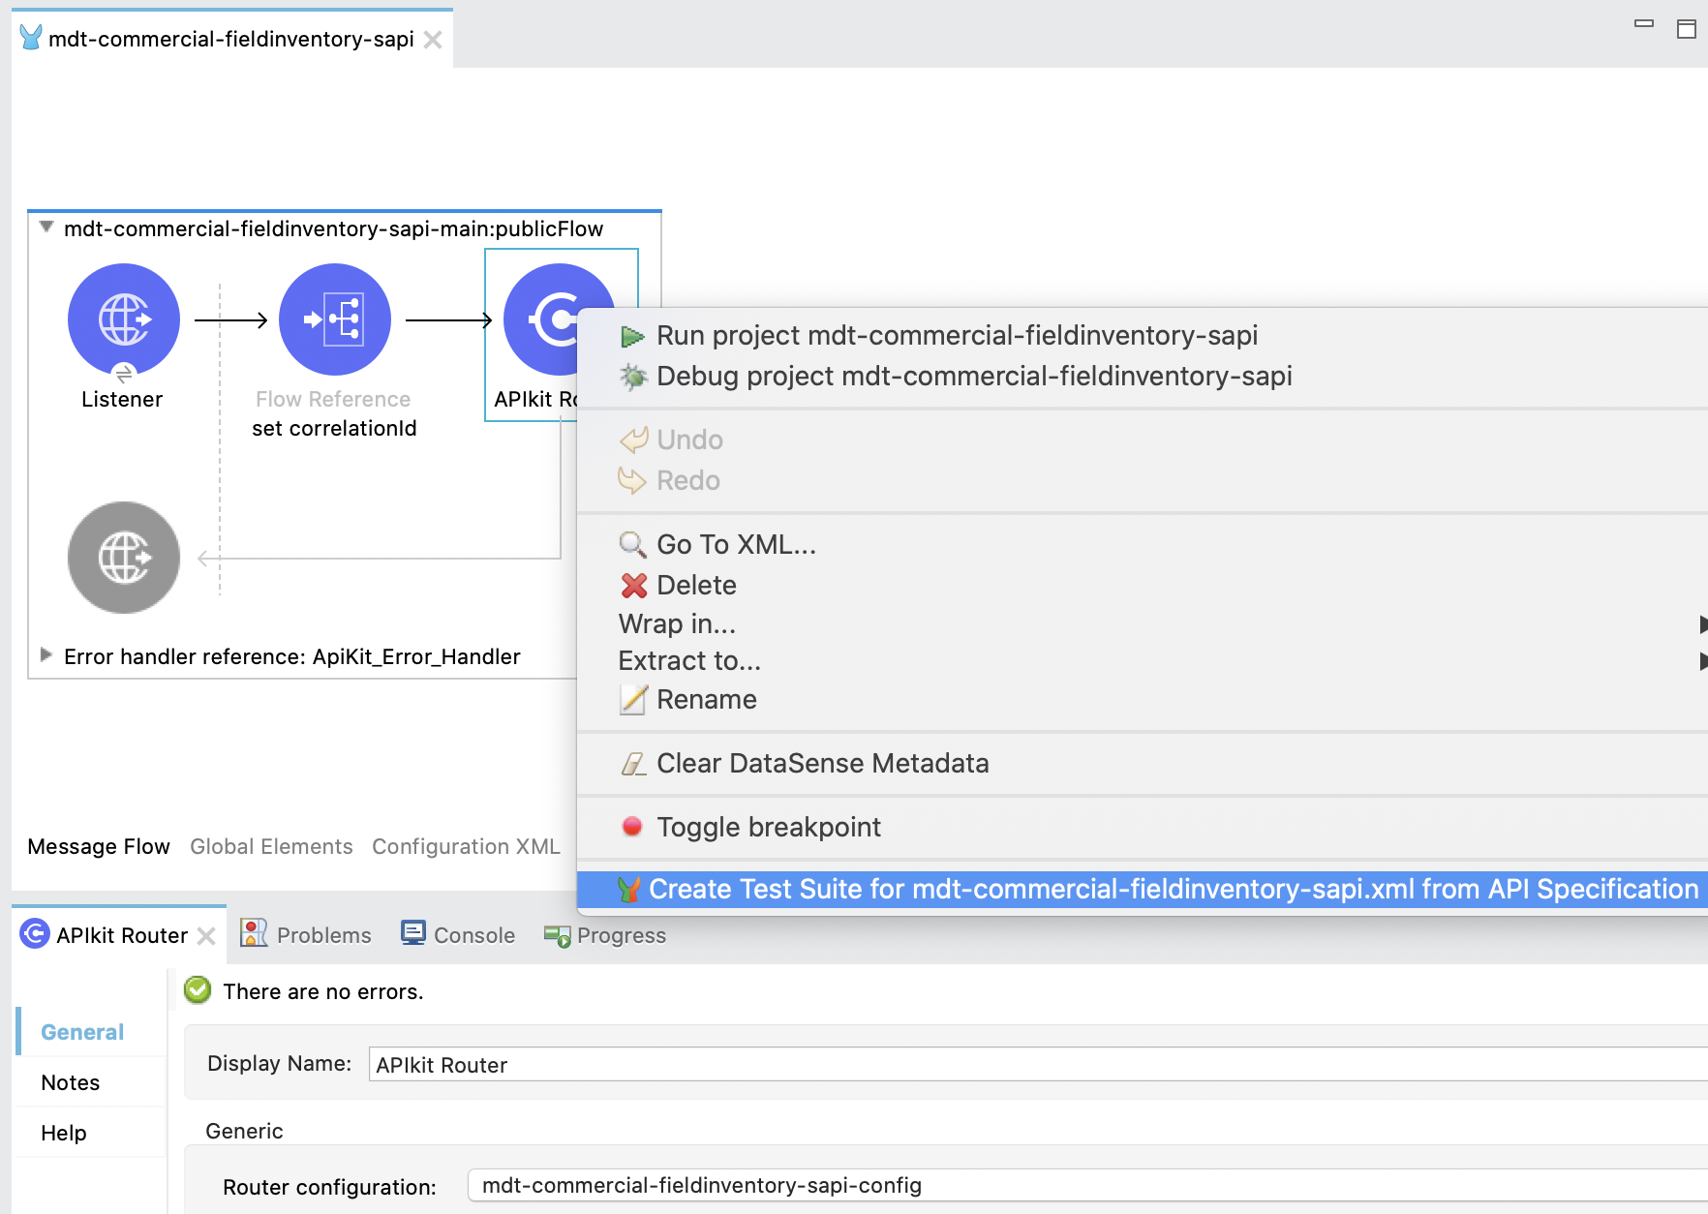

Add the test suite file XML in the folder src/test/unit with the basic MUnit Tests. Also, adds the response file for each flow in the RAML in the folder source/test/resources/scaffolder/response.

If you have defined examples for the responses in the API spec, the example file will be created with the structure and values defined in this file.

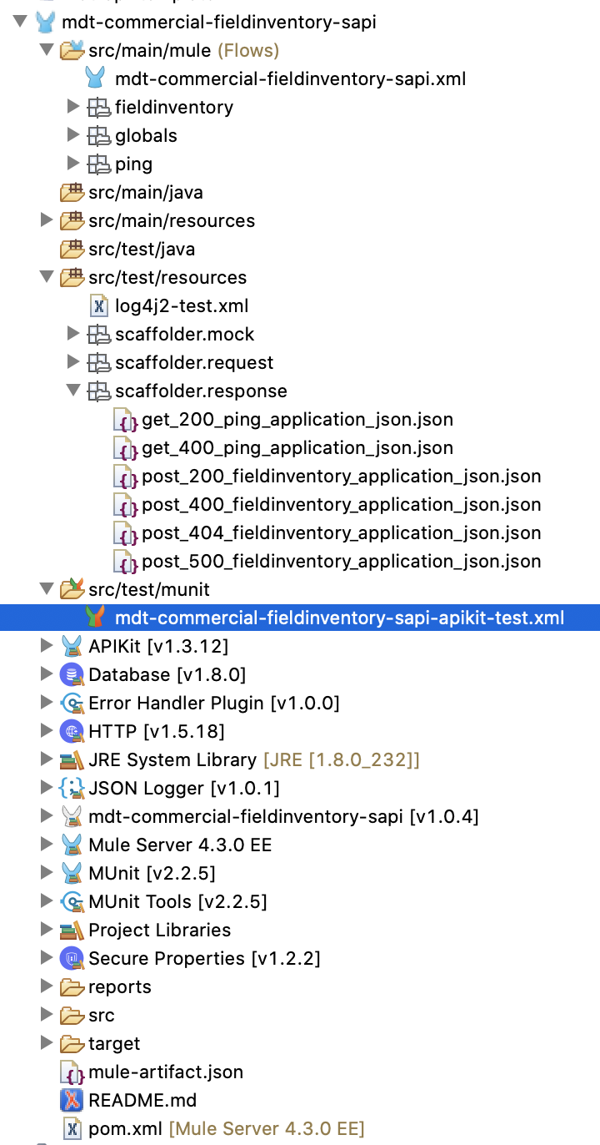

Each MUnit Test has an HTTP Requests (pointing to the endpoint and to Asset that processors for the Status Code and the Payload, in Execution and Validation scopes respectively.

MUnit Test scopes base documentation: <https://docs.mulesoft.com/munit/2.2/munit-test-concept>

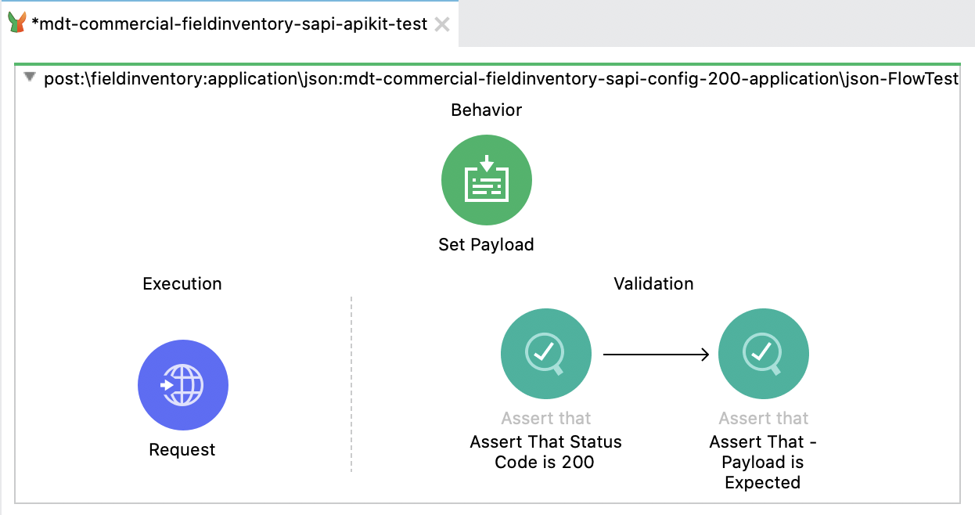

# Creating Test Suite for a Flow

Right Click on a given flow to generate the Test suite for that flow

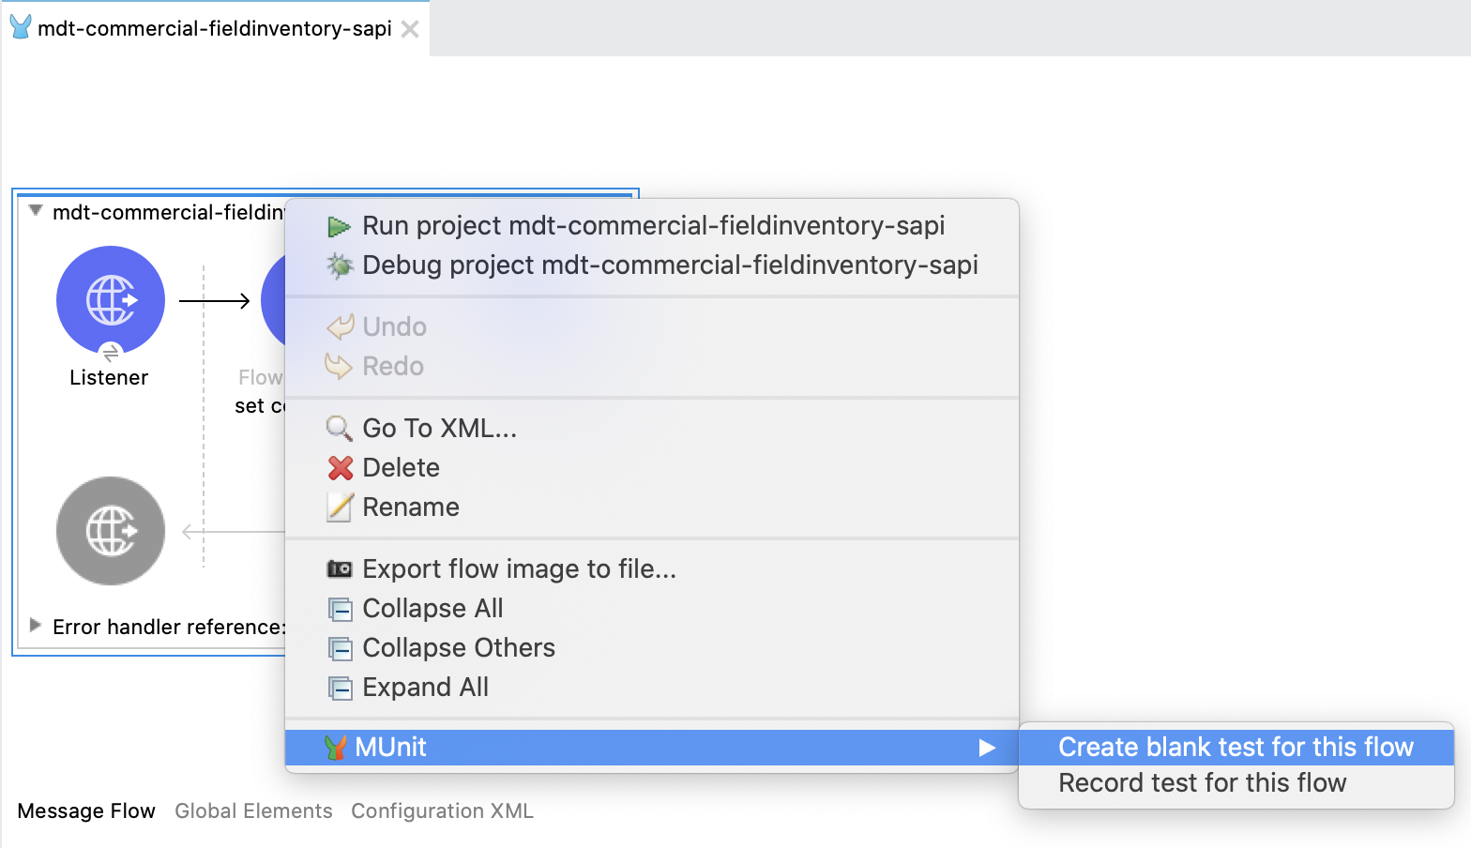

# Creating Test Suite for selective flows

Select the Mule Application and then navigate to **File -> New -> MUnit Test** to generate test suite for selective flows.

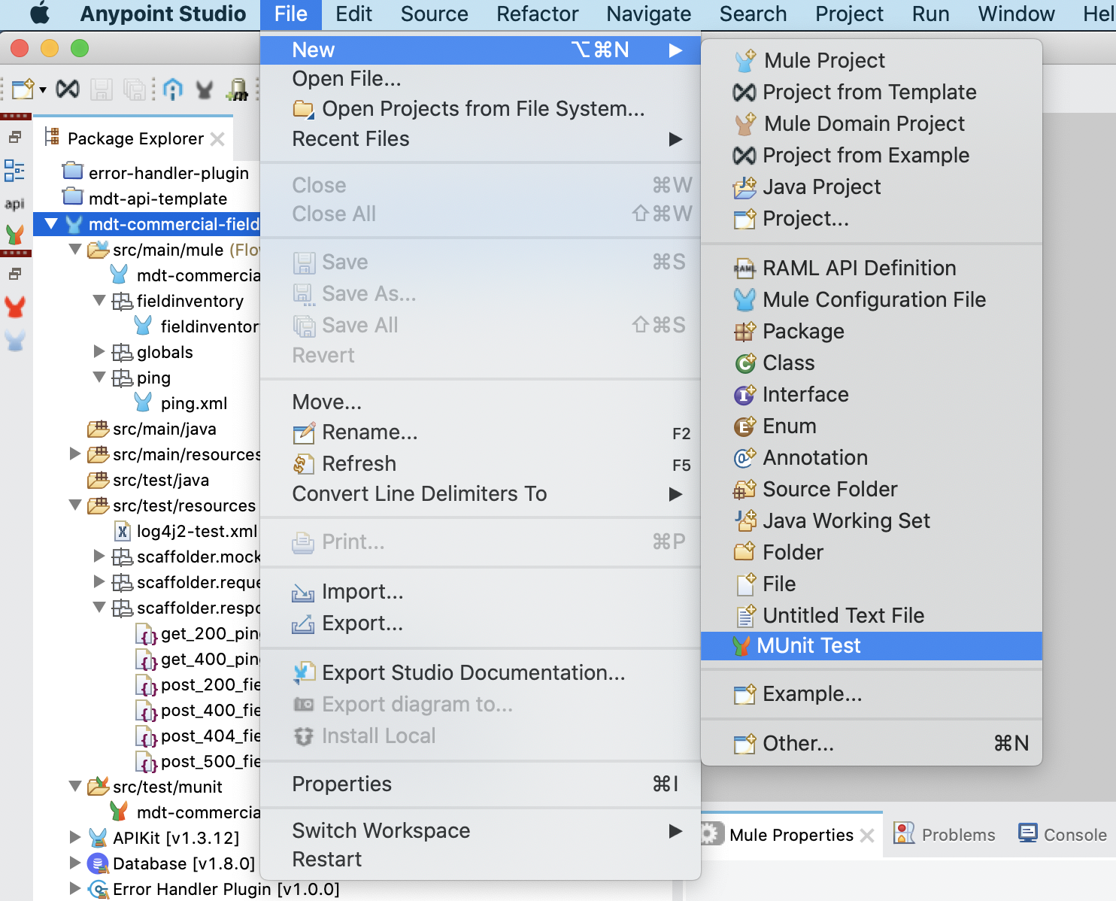

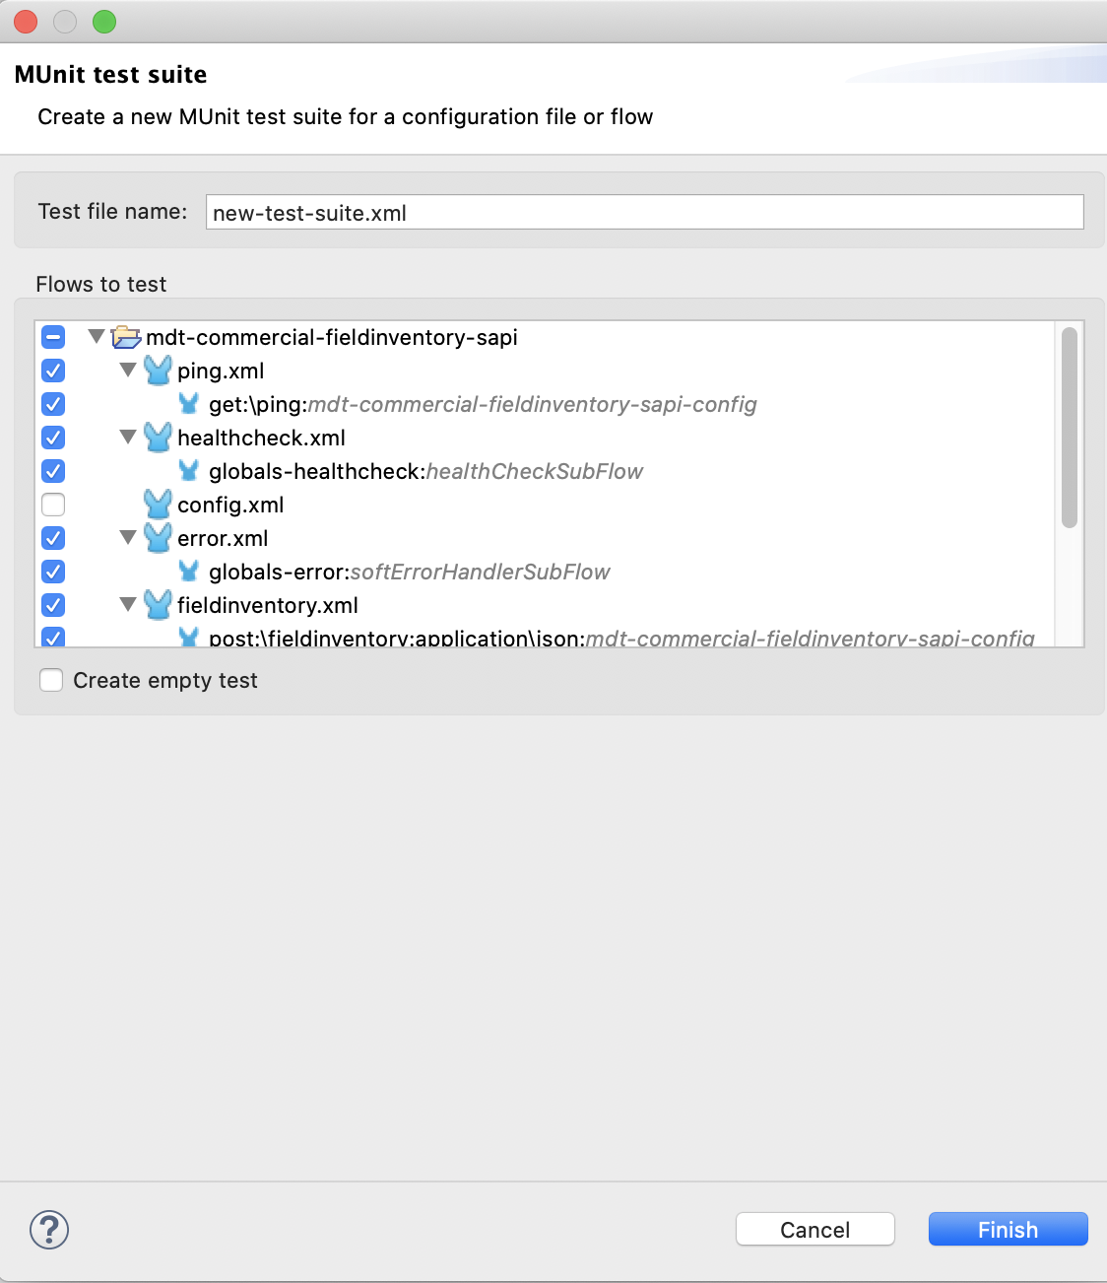

# Creating Testcase by recording the test

In the below example, we have a simple mule flow listening for an HTTP request and then we are doing a Database Select operation and then a transformation.

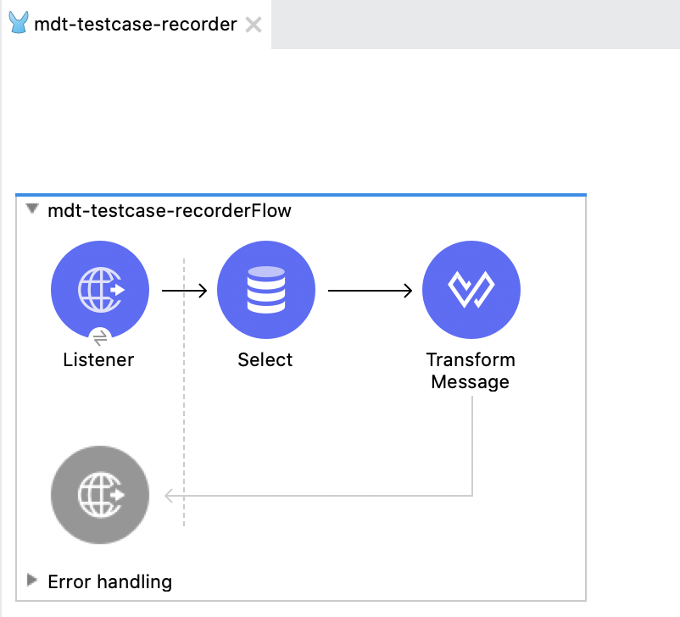

In order to record a test for this flow, please follow the below instructions.

1. Right Click on the flow for which test needs to be recorded.

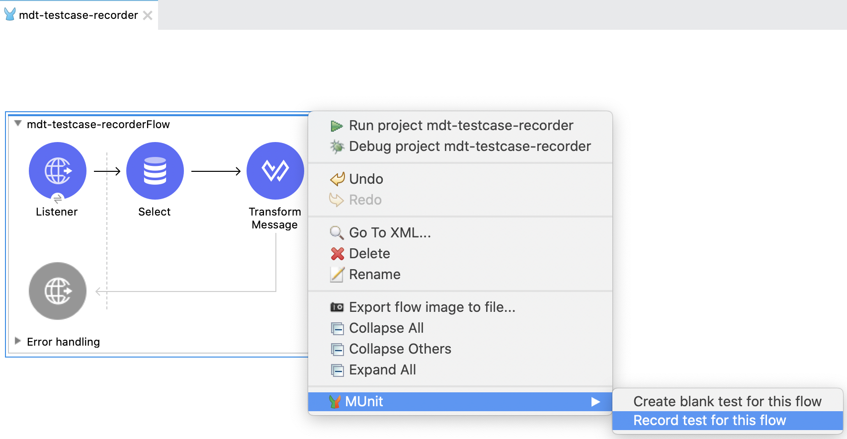

1. Select “Record test for this flow”. Then the service will start automatically in the listening mode to record the test case.

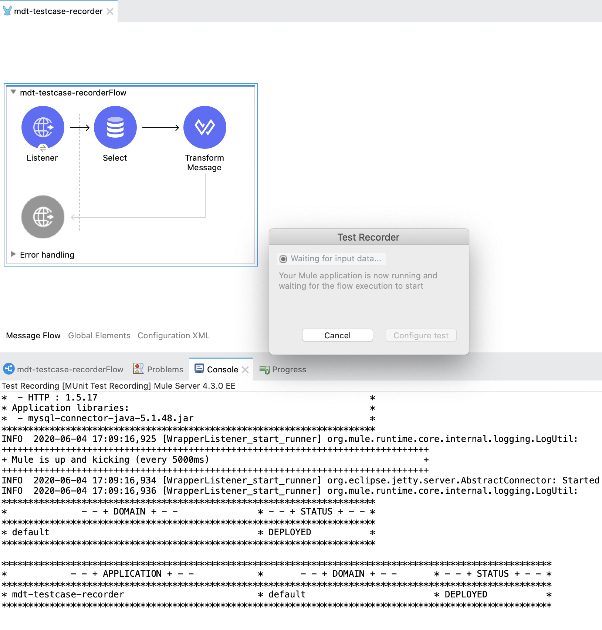

1. Invoke the service from any api client (for example postman).
2. After sending the request, the “configure test” button will get highlighted.

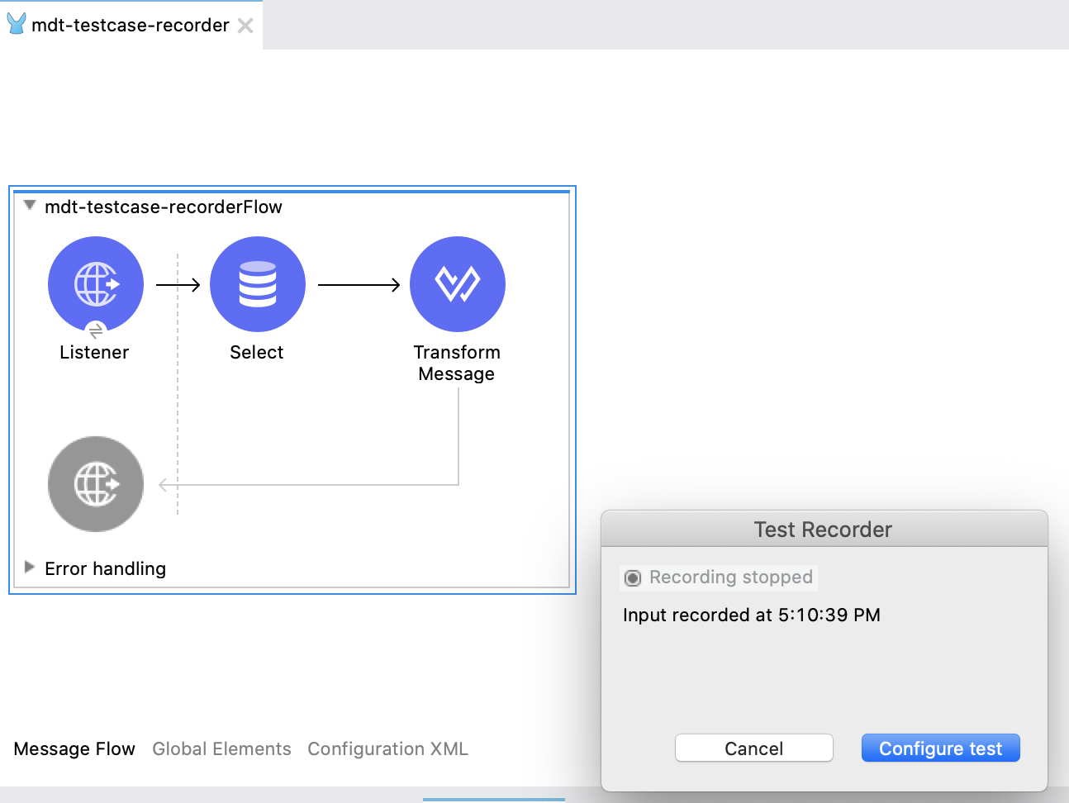

1. Click on the “Configure test”. You will get the below prompt.

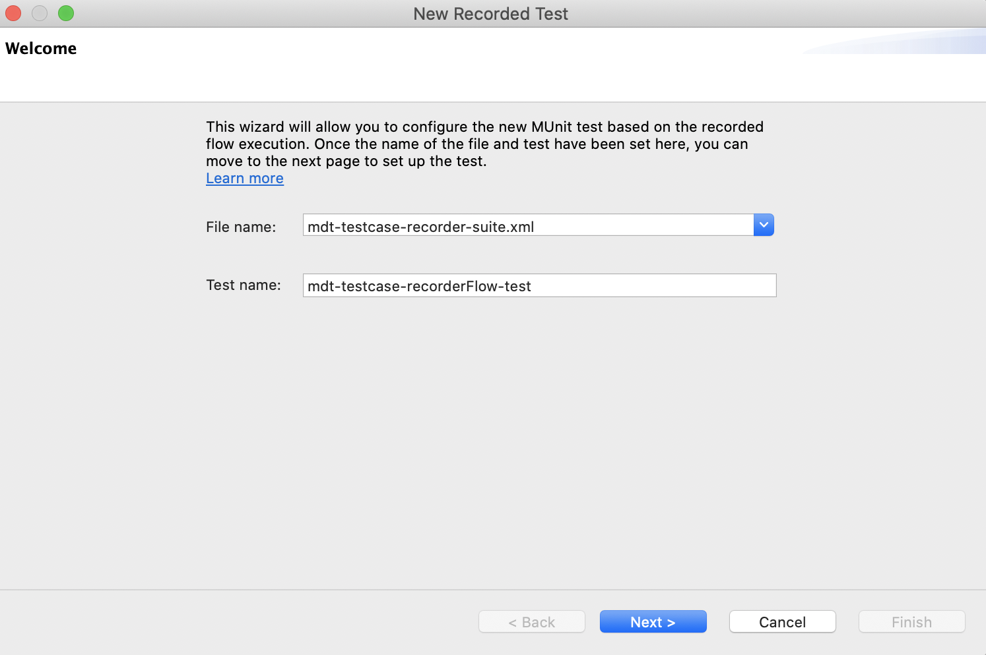

1. Enter the “Test name” and click “Next”.

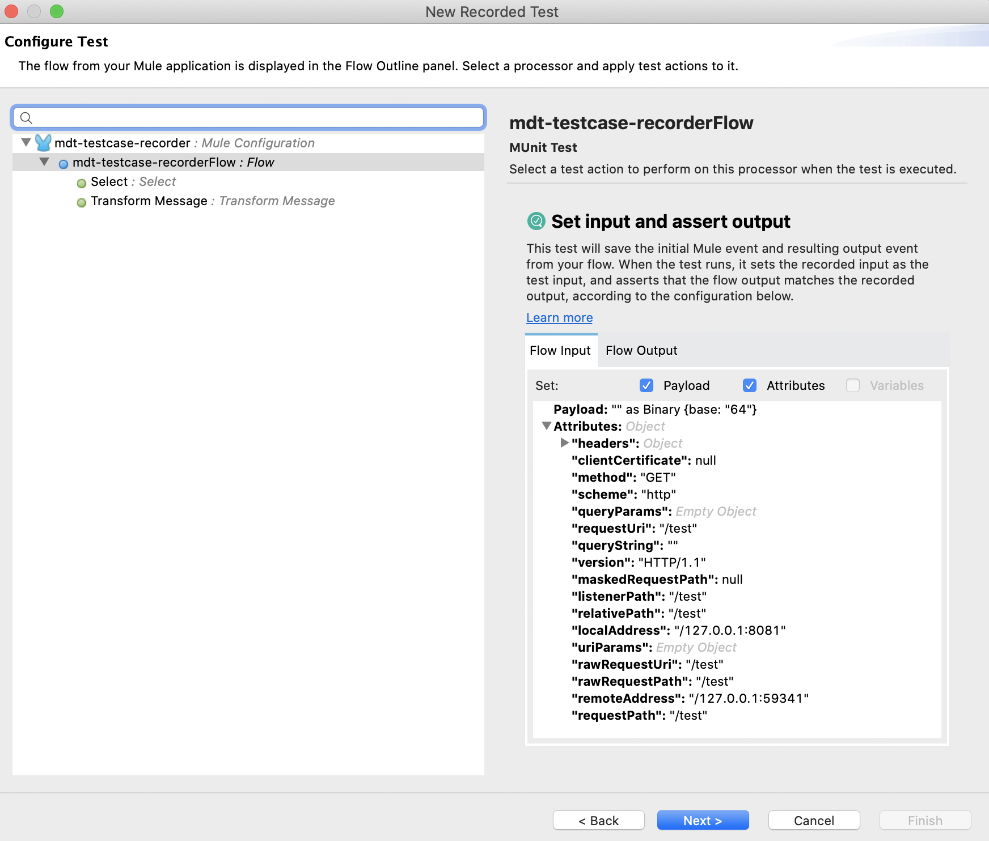

1. Enable the HTTP Attributes & Payload checkbox to record the headers and payload.
2. In order to mock the database, “click” the Database operation and then select the “Mock this processor”. Make sure to enable the Payload checkbox, to save the payload for the mock processor.

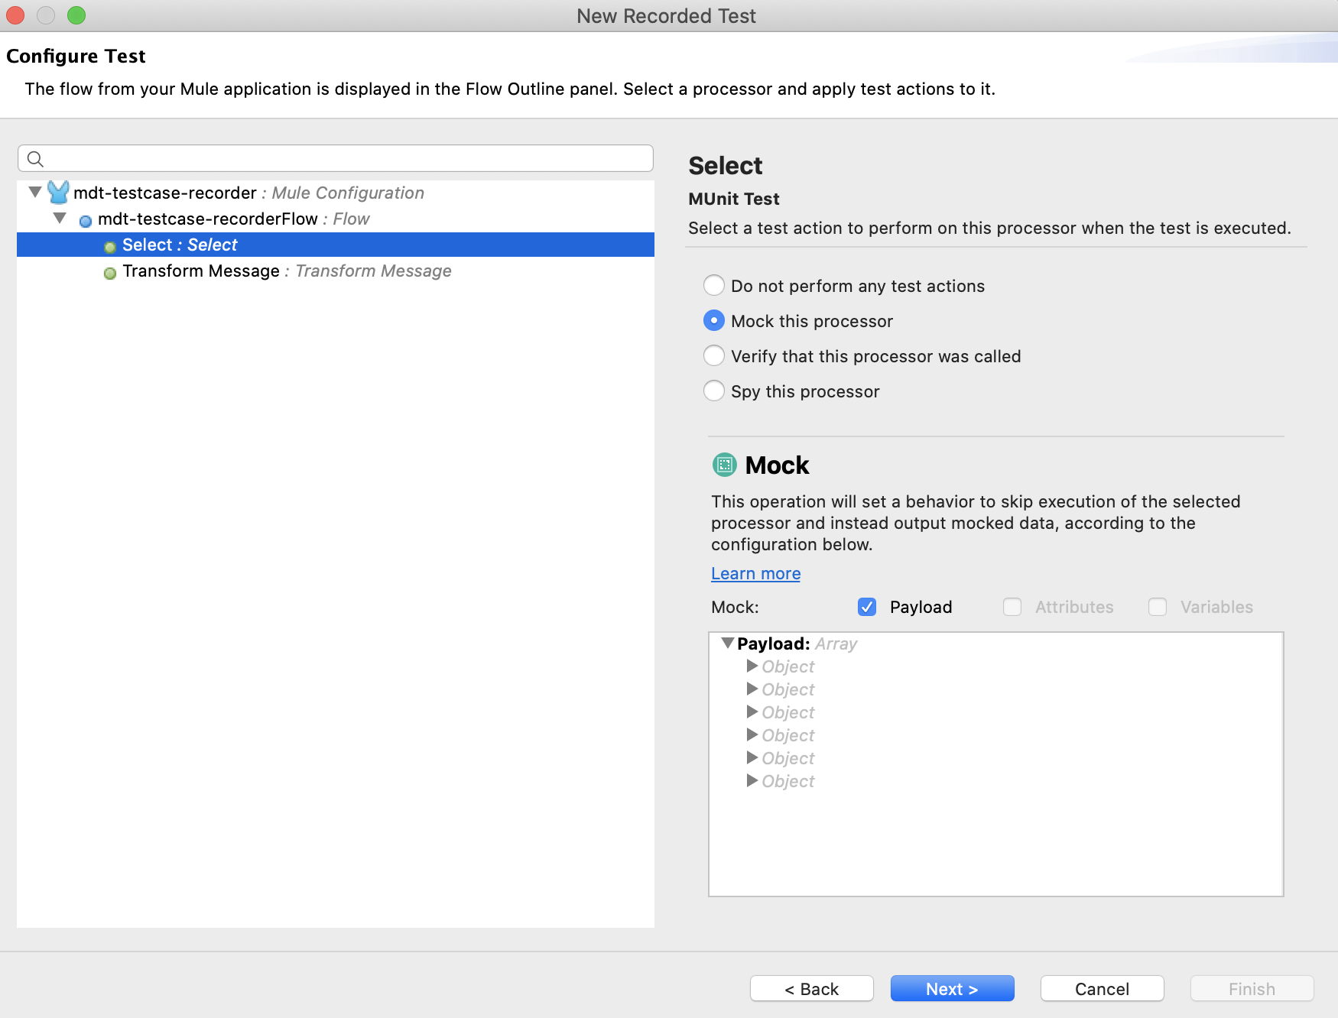

1. Click Next and then Finish.

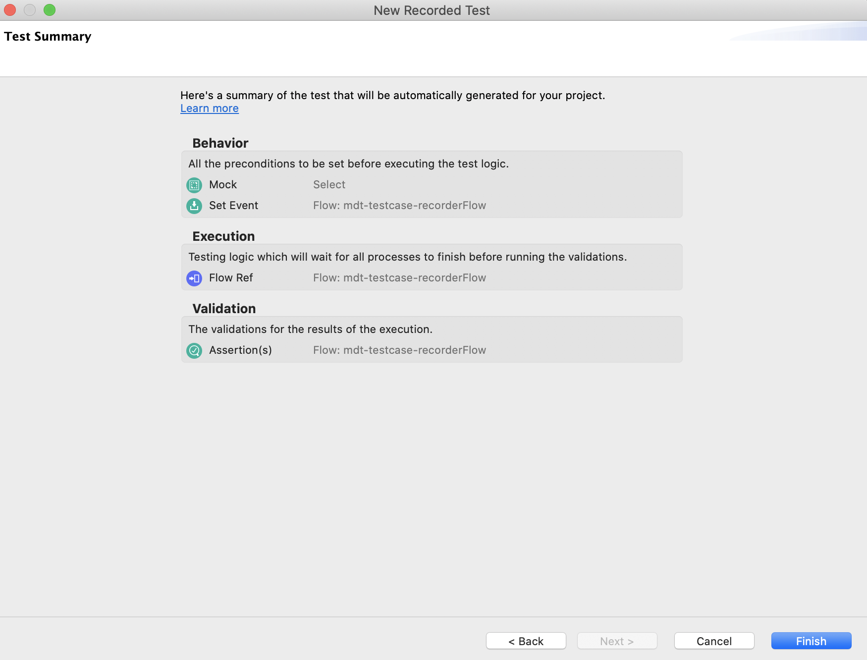

1. A test case has been created along with the mock processor.

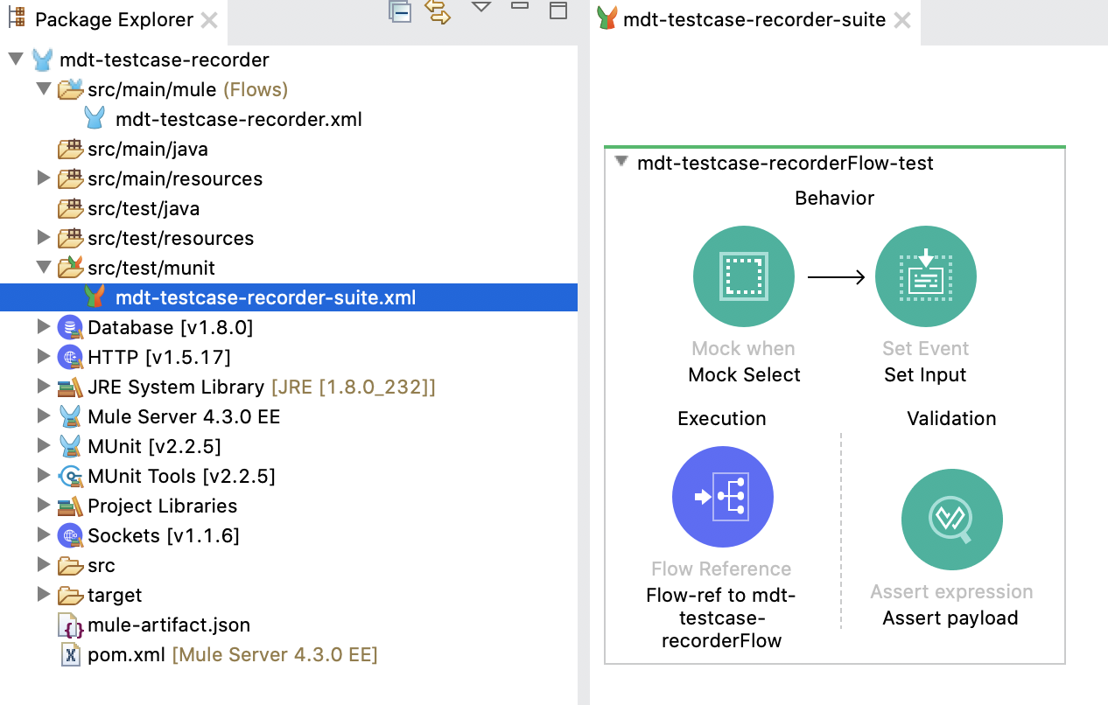

Now I can go ahead and run this test case without any further changes.

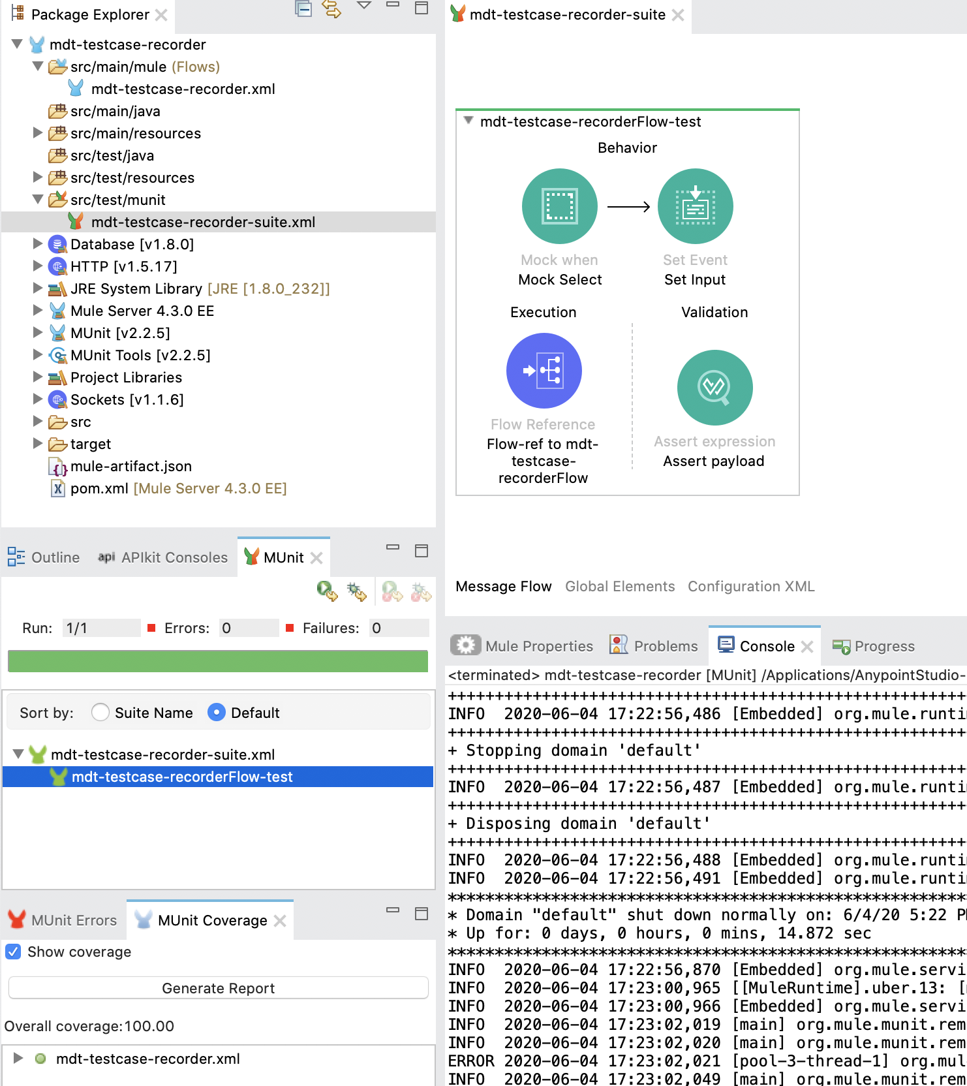

# MUnit Event Processors

# Assert

The Assert That Event Processor allows you to run assertions in order to validate the state of a Mule Event’s content. Base documentation:  <https://docs.mulesoft.com/munit/2.2/assertion-event-processor>

# Assert Payload

If the test suite is generated from the API Kit Router, by default the assert **Expression** and **Is** values are defined as:

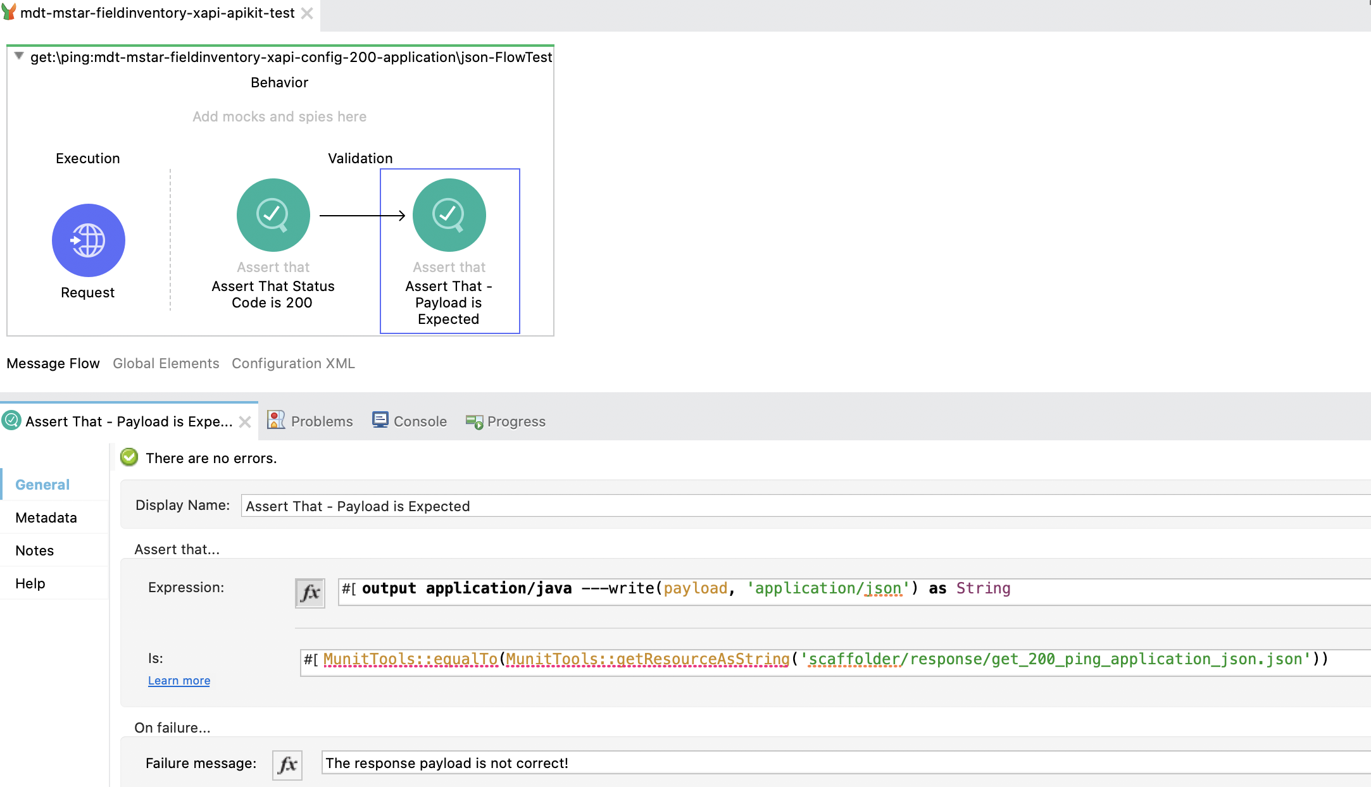

**XML configuration**

<munit-tools:assert-that expression=*"#[output application/java ---write(payload, 'application/json') as String]"* is=*"#[MunitTools::equalTo(MunitTools::getResourceAsString('scaffolder/response/get_200_ping_application_json.json'))]"* message=*"The response payload is not correct!"* doc:name=*"Assert That - Payload is Expected"* />

To avoid string assert errors configure the processor as follow, use the payload “AS IS” without converting to a string, and get the response file with readUrl function without transform to a string.

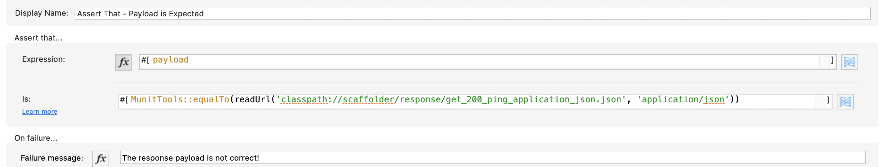

**XML configuration:**

<munit-tools:assert-that expression=*"#[payload]"* is=*"#[MunitTools::equalTo(readUrl('classpath://scaffolder/response/get_200_ping_application_json.json', 'application/json'))]"* message=*"The response payload is not correct!"* doc:name=*"Assert That - Payload is Expected"* />

Store the payload example files in the folder src/test/resources/scaffolder/response.

# Mock when

The ‘Mock When’ processor allows you to mock an Event Processor when it matches the defined name and attributes. Base documentation:  <https://docs.mulesoft.com/munit/2.2/mock-event-processor>

# Unit Testing Best Practices

* Identify Positive Testing Scenarios
* Identify Negative Testing Scenarios
* Create a Test Case for each Condition
* Mock External Dependencies
* Don't depend on the execution environment
* Good percentage of Code Coverage

# Mocking External dependencies

# Mocking HTTP request

The example below shows the mocking of an HTTP request.

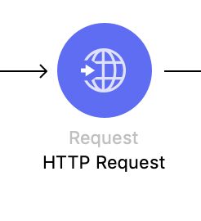

**XML Configuration**

<http:request method=*"GET"* doc:name=*"HTTP Request"* doc:id=*"024fe2d0-5b6f-46d6-adbb-c6713d916127"* path=*"#['/united/flights/SFO']"* config-ref=*"HTTP_Request_configuration"*/>

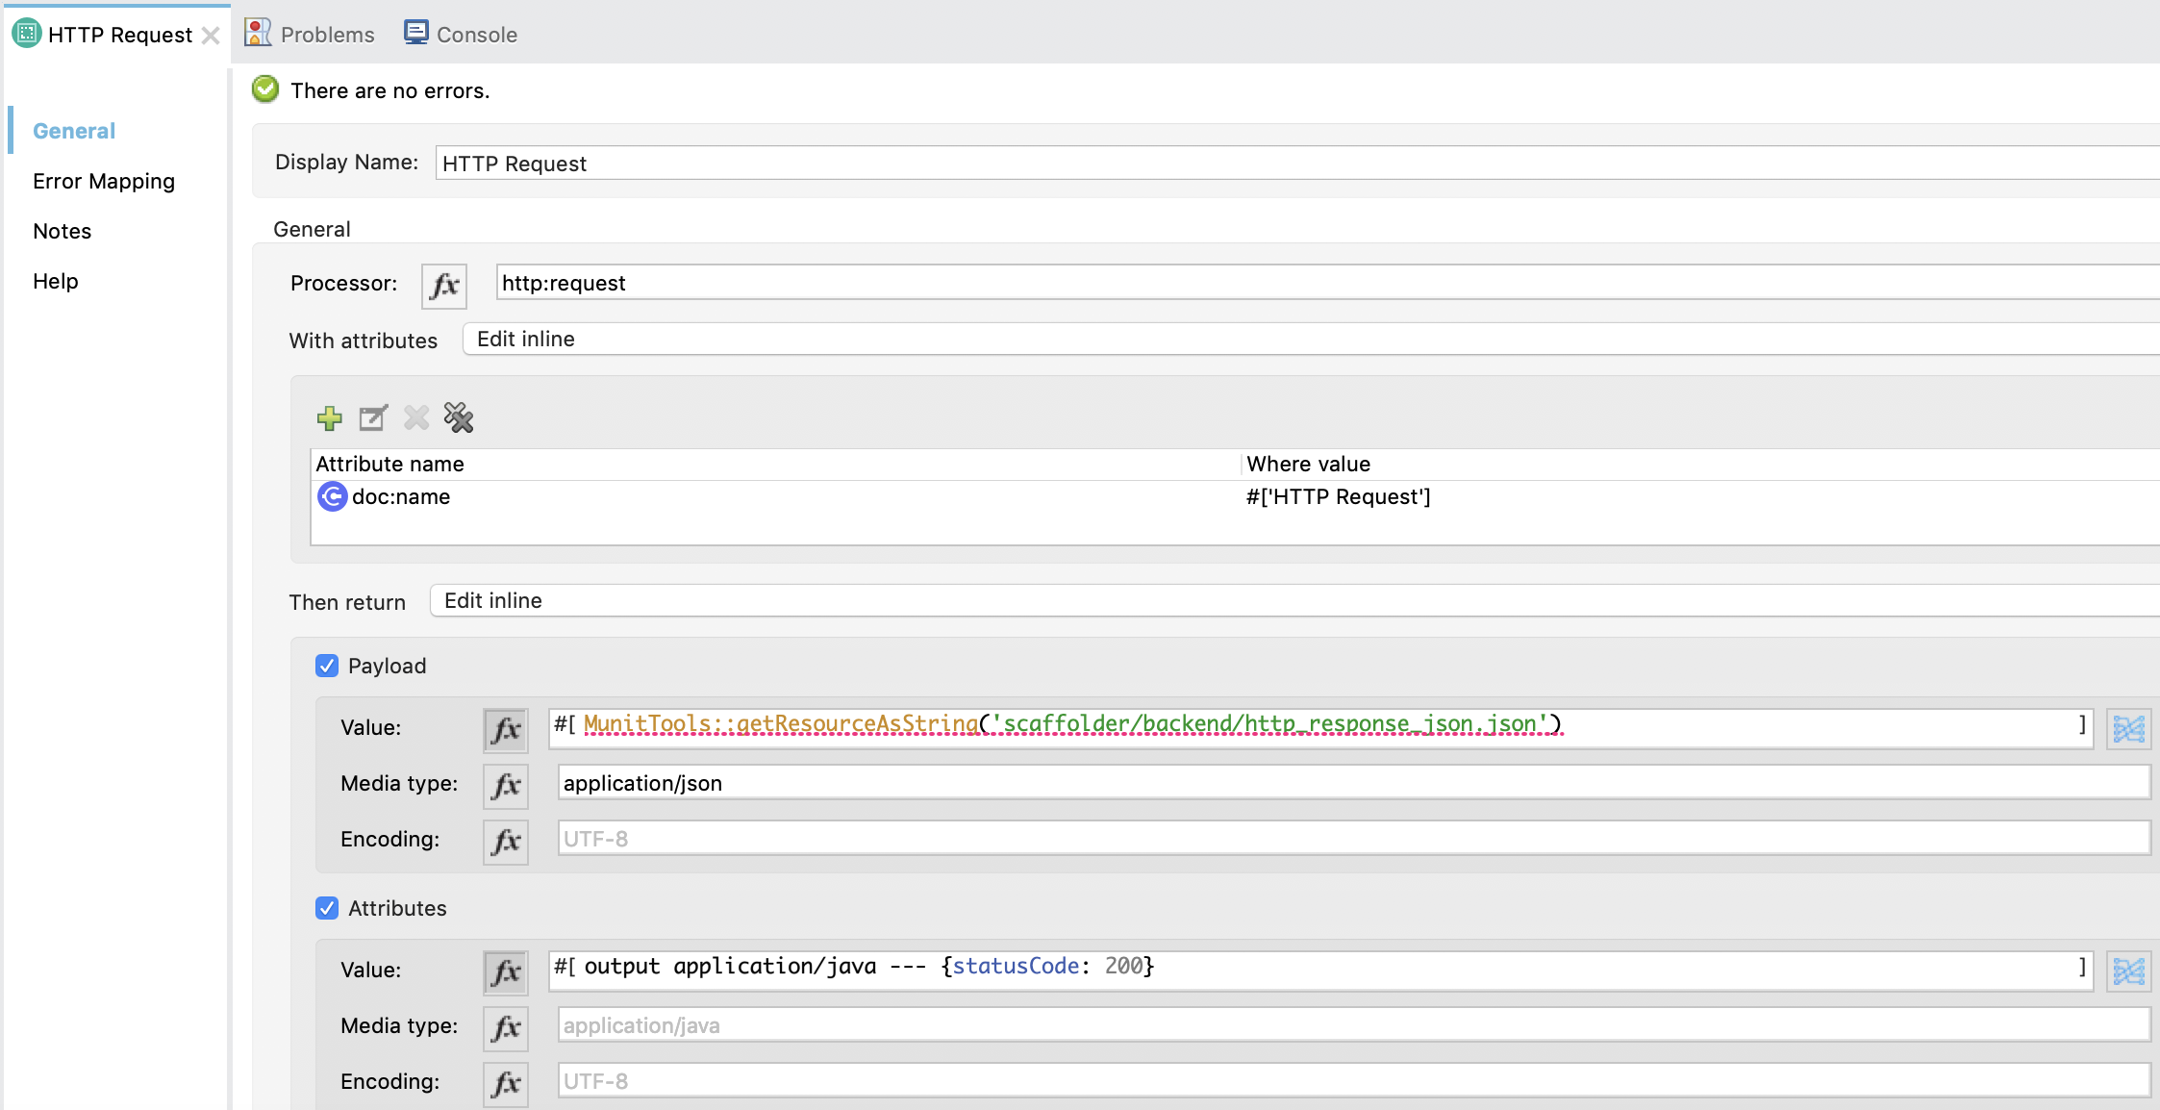

Also, you can identify the processor to mock with the **doc:id** attribute

Mock the return values, the payload and the attribute Status Code for the success flow of the HTTP request to legacy-application.

**XML Configuration**

<munit-tools:mock-when doc:name=*"HTTP Request"* doc:id=*"8f06af6c-b1a0-4c7e-aee8-10c5aecac091"* processor=*"http:request"*>

<munit-tools:with-attributes >

<munit-tools:with-attribute attributeName=*"doc:name"* whereValue=*"#['HTTP Request']"* />

</munit-tools:with-attributes>

<munit-tools:then-return >

<munit-tools:payload value=*"#[MunitTools::getResourceAsString('scaffolder/backend/http_response_json.json')]"* mediaType=*"application/json"*/>

<munit-tools:attributes value=*"#[output application/java --- {statusCode: 200}]"* />

</munit-tools:then-return>

</munit-tools:mock-when>

# Mocking Database Select

For mocking a Database Select processor, use the doc:id/doc:name attribute to identify the processor to mock.

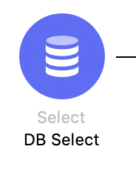

**XML Configuration**

<db:select doc:name=*"DB Select"* doc:id=*"fc2ce3f4-3fa8-4b4d-ba6a-8dd2bedf83b9"*

config-ref=*"Database_Config"*>

<db:sql>SELECT * FROM EMPLOYEE</db:sql>

</db:select>

Configure the then return payload section with the transformation to a string, and defining the media type as application/json.

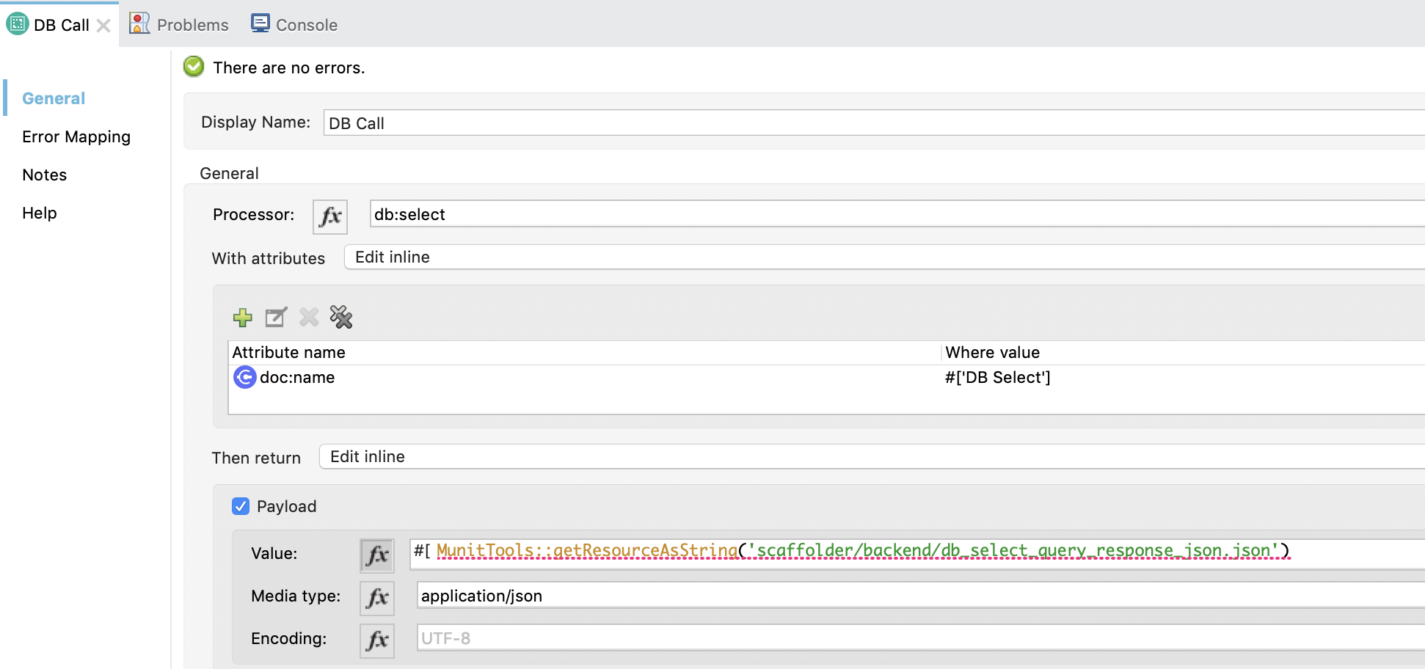

**XML Configuration**

<munit-tools:mock-when doc:name=*"DB Call"* doc:id=*"4b510c7d-9737-45ea-b6c2-ee23f43dde23"* processor=*"db:select"*>

<munit-tools:with-attribute attributeName=*"doc:name"* whereValue=*"#['DB Select']"* />

</munit-tools:with-attributes>

<munit-tools:then-return >

<munit-tools:payload mediaType=*"application/json"* value=*"#[MunitTools::getResourceAsString('scaffolder/backend/db_select_query_response_json.json')]"*/>

</munit-tools:then-return>

</munit-tools:mock-when>

# Mocking Web Service Consumer

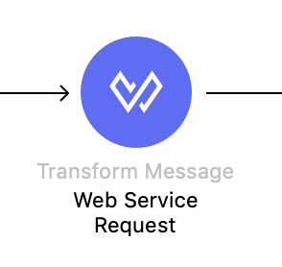

**XML Configuration**

<wsc:consume doc:name=*"Consume Web Service"* doc:id=*"e9edb7ea-2bf5-4c97-87b6-6b2b29b829f7"* config-ref=*"Web_Service_Consumer_Config"* operation=*"findFlight"*/>

Configure the then return payload section with the transformation to a string, and defining the media type as application/xml.

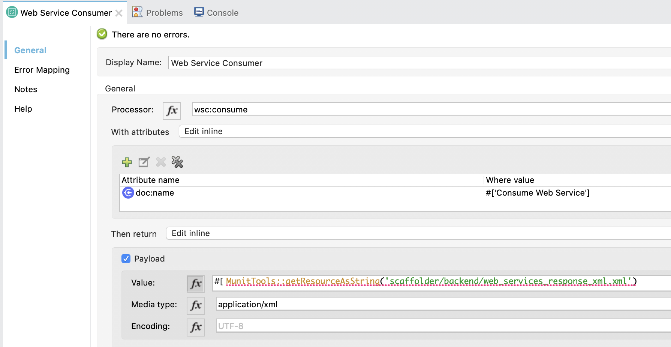

**XML Configuration**

<munit-tools:mock-when doc:name=*"Web Service Consumer"* doc:id=*"6008bfc0-25e8-4b91-9b4b-1b4d17c60ab0"* processor=*"wsc:consume"*>

<munit-tools:with-attributes >

<munit-tools:with-attribute attributeName=*"doc:name"* whereValue=*"#['Consume Web Service']"* />

</munit-tools:with-attributes>

<munit-tools:then-return >

<munit-tools:payload value=*"#[MunitTools::getResourceAsString('scaffolder/backend/web_services_response_xml.xml')]"* mediaType=*"application/xml"*/>

</munit-tools:then-return>

</munit-tools:mock-when>

# Mocking Read File

For mocking a Read File processor, for example, change the reference to the processor to mock and configure the return payload section as shown previously.

In the following example, the file is a csv.

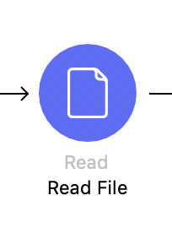

**XML Configuration**

<file:read doc:name=*"Read File"* doc:id=*"7cd349fd-e7d4-4cf7-b5b9-06954cc76956"* path=*"#['/Kishore/Development/MuleSoft/Studio-Workspaces/FileSystem/Input/names.csv']"*/>

Store the .csv example les in the folder src/test/resources/scaffolder/

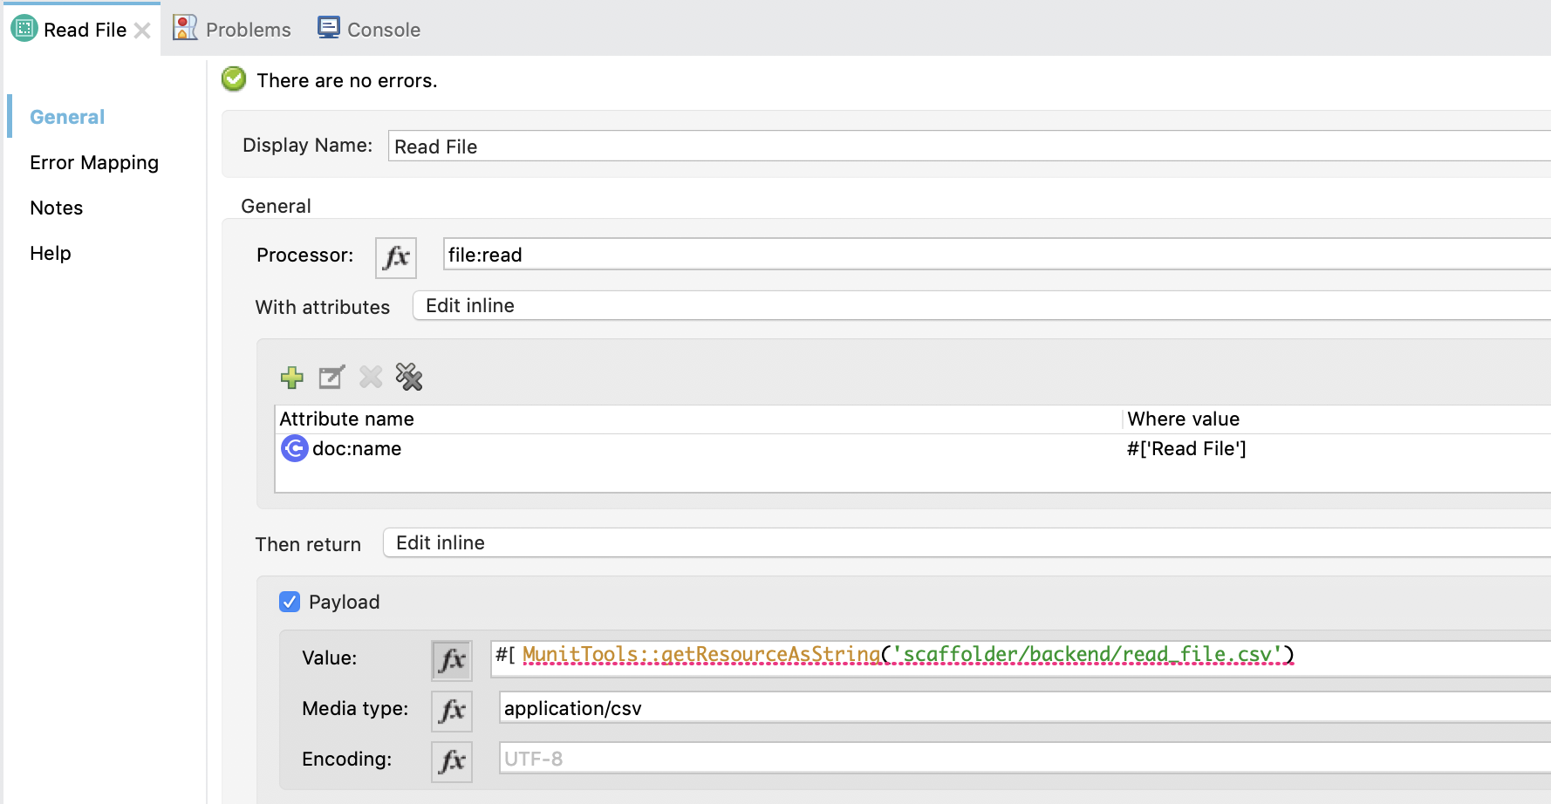

**XML Configuration**

<munit-tools:mock-when doc:name=*"Read File"* doc:id=*"7980de08-33ba-4e40-b723-fa0bf0c494ed"* processor=*"file:read"*>

<munit-tools:with-attributes >

<munit-tools:with-attribute attributeName=*"doc:name"* whereValue=*"#['Read File']"* />

</munit-tools:with-attributes>

<munit-tools:then-return >

<munit-tools:payload value=*"#[MunitTools::getResourceAsString('scaffolder/backend/read_file.csv')]"* mediaType=*"application/csv"* />

</munit-tools:then-return>

</munit-tools:mock-when>

Configure the then return payload section with the transformation to a string, and defining the media type as application/csv.

# Code Coverage

The Mule Maven Plugin runs the Code Coverage for MUnit. For configuration related information:

<https://docs.mulesoft.com/munit/2.2/munit-maven-plugin#to-enable-coverage>

<https://docs.mulesoft.com/munit/2.2/munit-coverage-report>

#### **Ignoring Files and Flows**

The MUnit Maven Plugin provides the functionality to ignore specific files and flows from the Code Coverage calculation.

<https://docs.mulesoft.com/munit/2.2/munit-maven-plugin#to-ignore-flows-for-coverage-report>

# Dataweave

It's important to note that most of the Mule Applications contain logic inside the Dataweave transformation. The code of the Dataweave component is not considered for the Code Coverage calculation.

This reinforces the idea that a high coverage percentage doesn't guarantee that the complete logic of the application has been tested.

# 

# MUnit Recommendations

# Always define the media type in a Mock

The response from an HTTP Request could be an **application/json**, so while mocking it’s a good practice to define the media type while mocking.

# Define the Environment Variables as Global Properties

The property **mule.env** that will be used to lookup the property files.

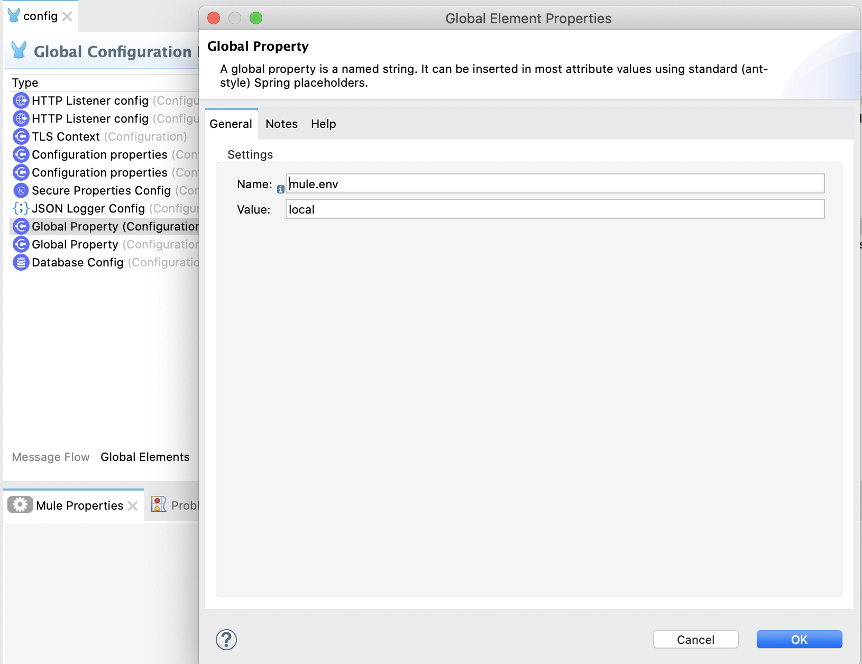

# Use Verify Event Processors

If the flow being tested calls a REST API or use a Connector, is better to verify that this connector is being called and it's not mocked.

<https://docs.mulesoft.com/munit/2.2/verify-event-processor>

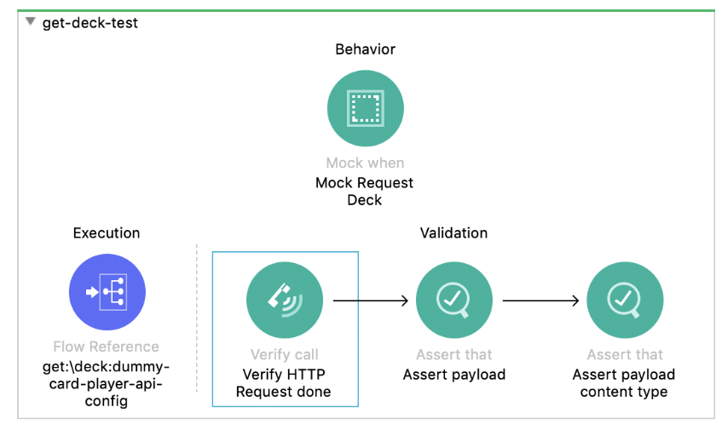

# Assert a payload when it contains a timestamp

A Mule Flow could generate a payload where one field is a timestamp generated with the **now()** function. In that case, asserting the object with the method **equalTo** won't work, as we can't generate the same timestamp that was created inside the flow.

In this case, asserting the fields of the payload, one by one, is the best option.

# Test Connectivity Errors

To cover a case like that, a Mock of the connector could throw an error.

|  |
| --- |
| <munit-tools:mock-when doc:name="Mock Request Deck" doc:id="44886c53-0575-47ba-98f2-2f3fb7a01237" processor="http:request">                  <munit-tools:with-attributes>                      <munit-tools:with-attribute attributeName="method" whereValue="GET" />                  </munit-tools:with-attributes>                  <munit-tools:then-return>                      <munit-tools:error typeId="HTTP:CONNECTIVITY"/>                  </munit-tools:then-return>              </munit-tools:mock-when> |

<https://docs.mulesoft.com/munit/2.2/mock-event-processor#mocking-errors>

# References

<https://docs.mulesoft.com/munit/2.2/>

<https://docs.mulesoft.com/munit/2.2/spy-processor-concept>

<https://docs.mulesoft.com/munit/2.2/munit-coverage-report>

<https://docs.mulesoft.com/munit/2.2/mock-message-processor>

<https://docs.mulesoft.com/munit/2.2/munit-maven-plugin-configuration>

<https://docs.mulesoft.com/munit/latest/assertion-message-processor>

<https://www.mulesoft.com/exchange/org.mule.examples/munit-short-tutorial/>

<https://www.mulesoft.com/exchange/org.mule.examples/testing-apikit-with-munit/>